**Servidores REMS**

|  |  |  |  |
| --- | --- | --- | --- |
| Pais | IP | Servidor | Ambiente |
| El Salvador | 10.233.53.149 | LACSLVPIPVAS017 | Producción |
| 10.233.52.25 | LACSLVBCCVAS005 | COB |
| Costa Rica | 10.233.77.77 | LACCRIPTPRVAS02 |  |
| Panamá | 10.233.61.101 | LACPANTAPVAS009 |  |
| Nicaragua | 10.233.56.25 | LACNICPESER001 | Producción |
| 10.233.56.157 | LACNICCLCVDB015 | COB |

* Costa Rica y Panamá son servidores nuevos, ya están registrados en aperture como Pre-Producción.
* El servidor viejo de Panamá el SWIFT_BACKUP (10.233.61.42) solo corre el robot ACH 🡪 acuerdo con wintel que lo dejen parchar junto con los REMS, aunque activen las interfaces no funcionaran.
* Los servidores de Costar Rica ya no deben estar iniciadas las interfaces:
  + 10.233.77.21 - SWIFTNT2
  + 10.233.77.70 - LACCRIHEPVAS062

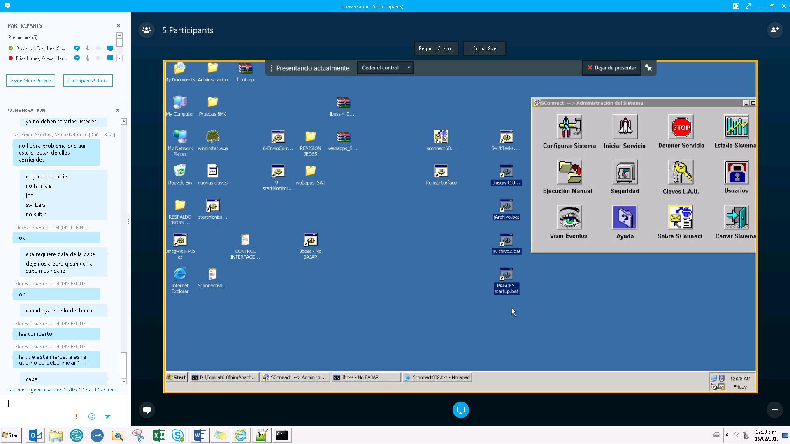

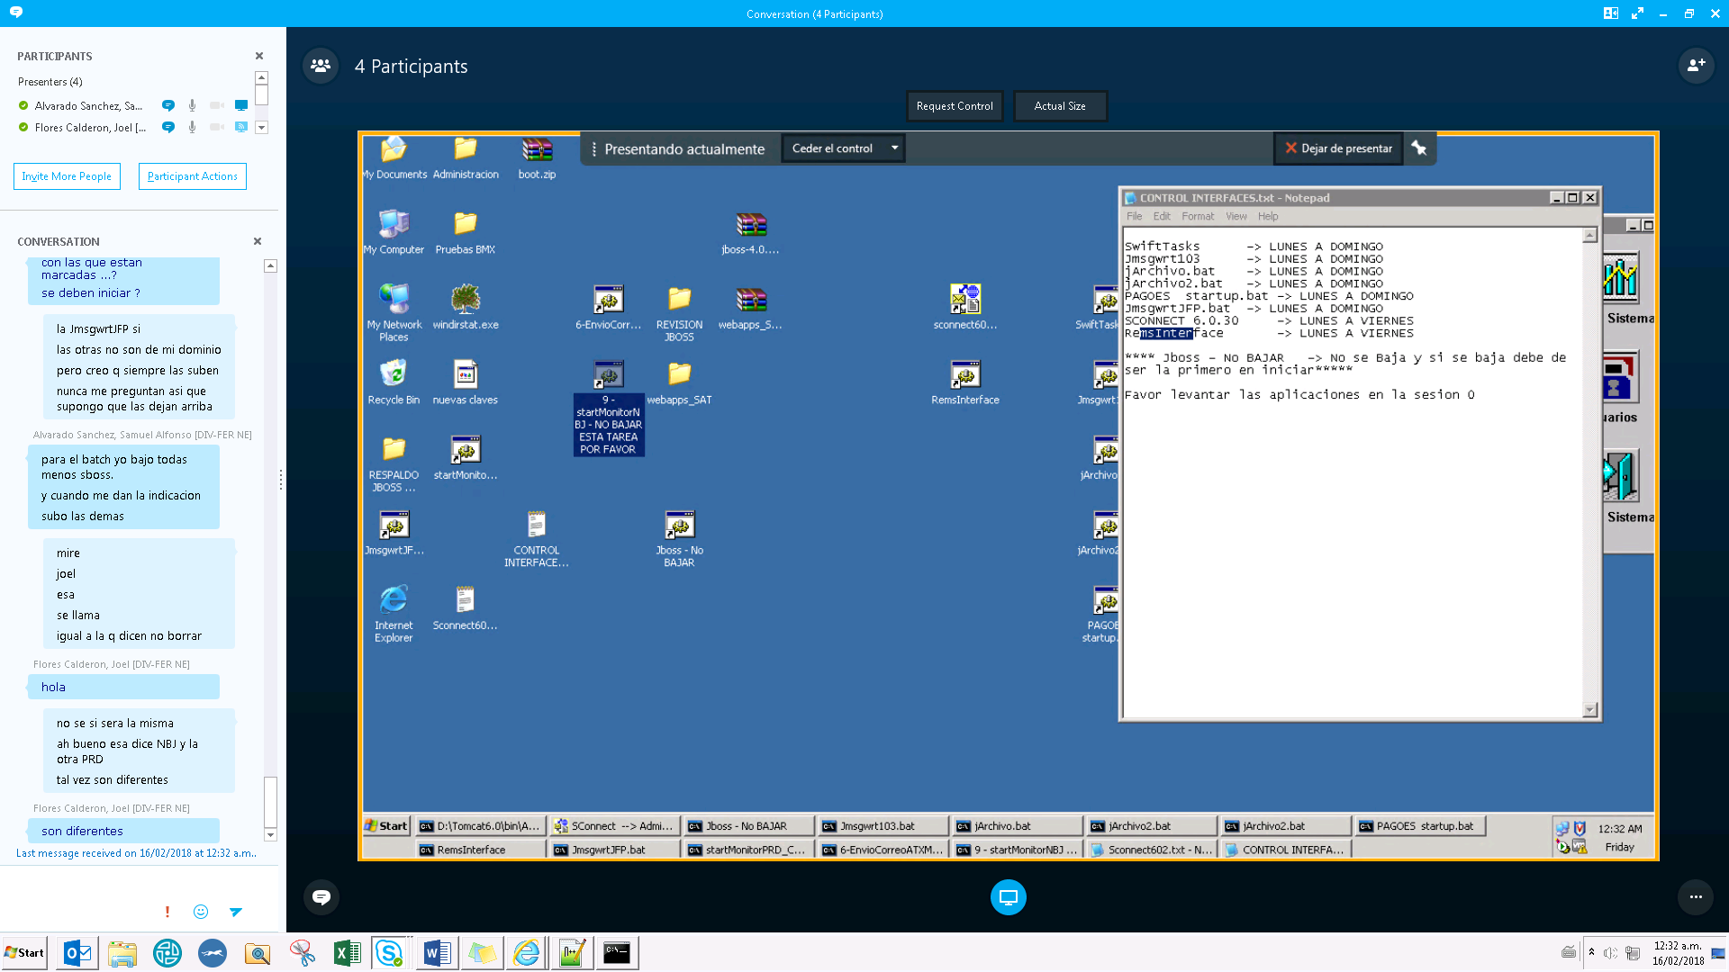

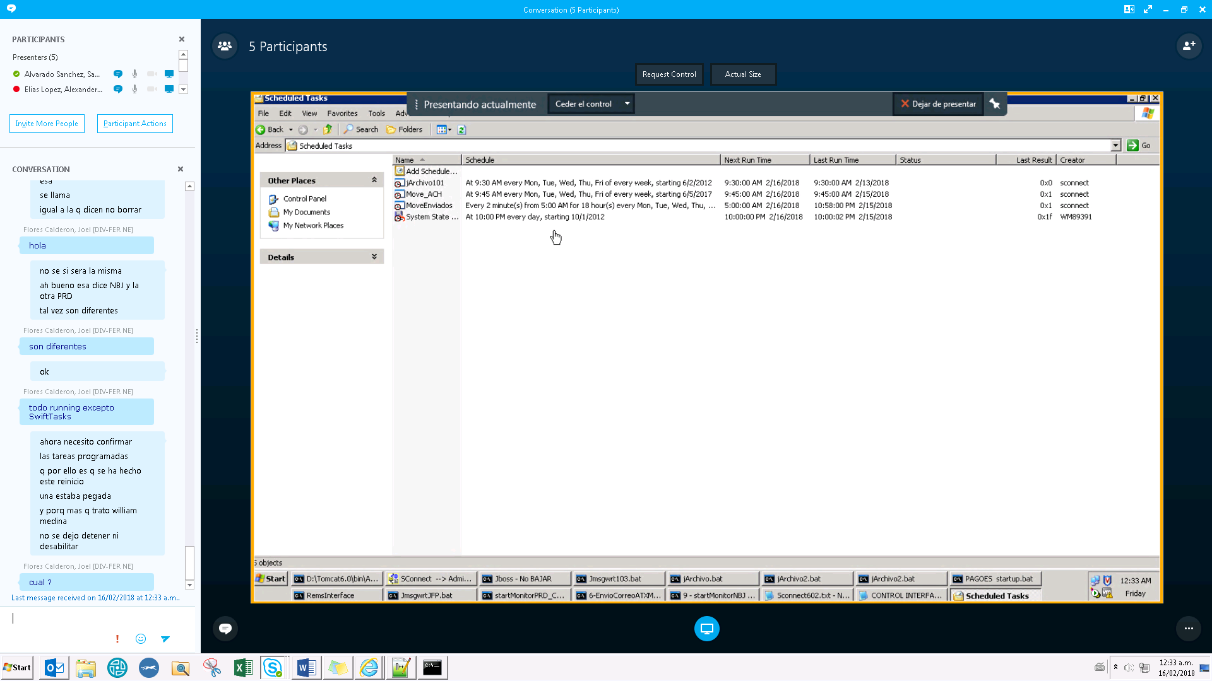

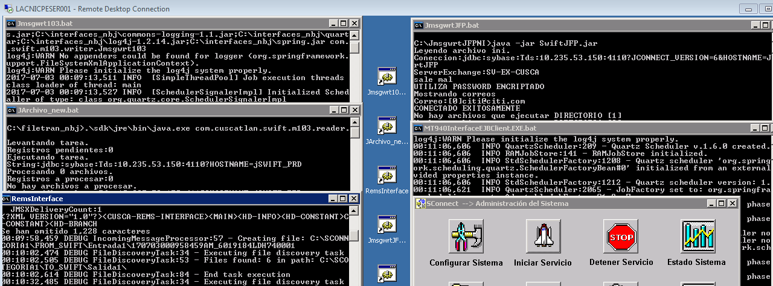

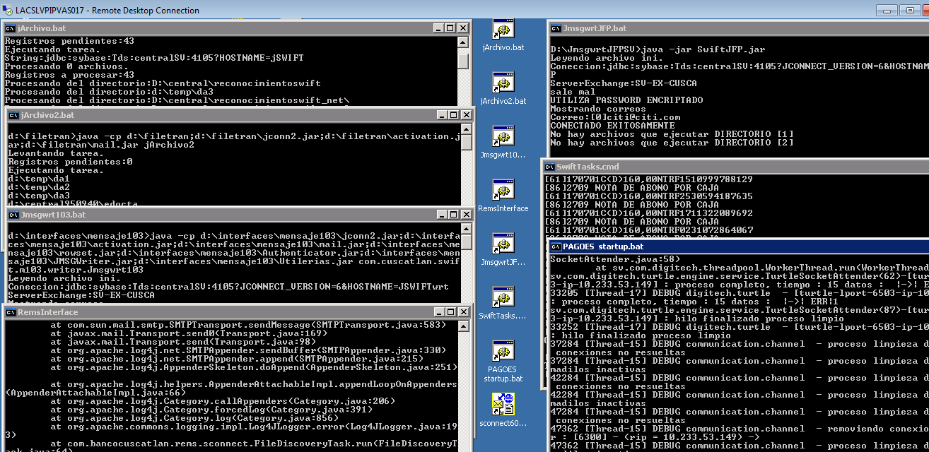

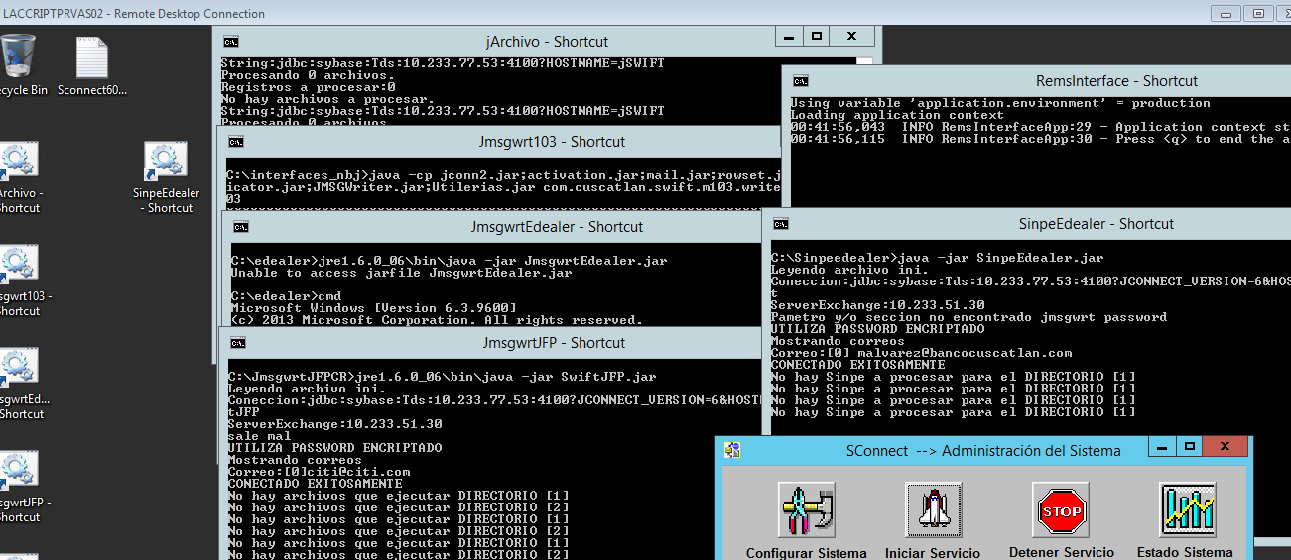

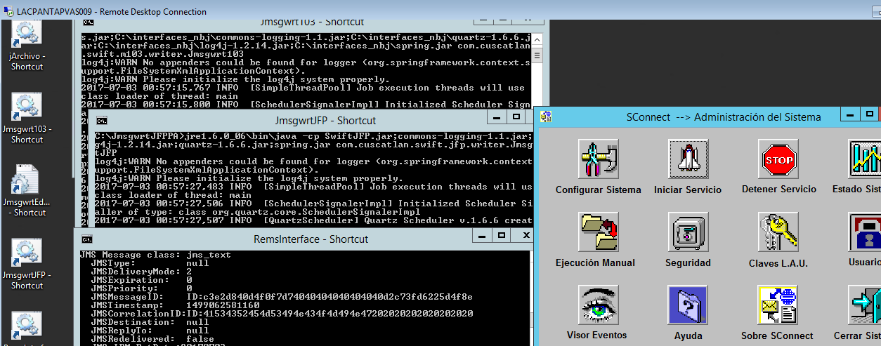

MENSAJE 103

* cob_comext..ce_mensaje_103 ***(Lo ingresado en Internacional)***
* cob_comext..ce_mensaje_103_nb ***(Lo ingresado en Netbanking Java)***
* cob_comext..ce_mensaje_103_jfp ***(Lo ingresado en Citibank On Line o CBOL)***

Problemas propios de REMS

Reportar a: *ICG CL LATAM Rems [dl.icg.cl.icg.cl.latam.rems@imcla.lac.nsroot.net](mailto:dl.icg.cl.icg.cl.latam.rems@imcla.lac.nsroot.net)

Ejemplo de error propio de REMS:

No pueden autorizar la transferencia

El manual del proceso de consultas a GI para mensajes manuales.

Hay 3 acciones a realizar:

* Enviar el mensaje hacia la cola de Hold
* Autorizar el mensaje
* Visualizar las palabras identificadas por Global Interdict
* Si al momento de la autorización del mensaje se elige autorizar pese a la notificación de que existen palabras identificadas por

Global Interdict, se deberá presionar la tecla **función F6** para confirmación.

* Esta acción solicitará la confirmación de la autorización, para lo cual se debe presionar nuevamente la tecla **función F6.**



Panamá:

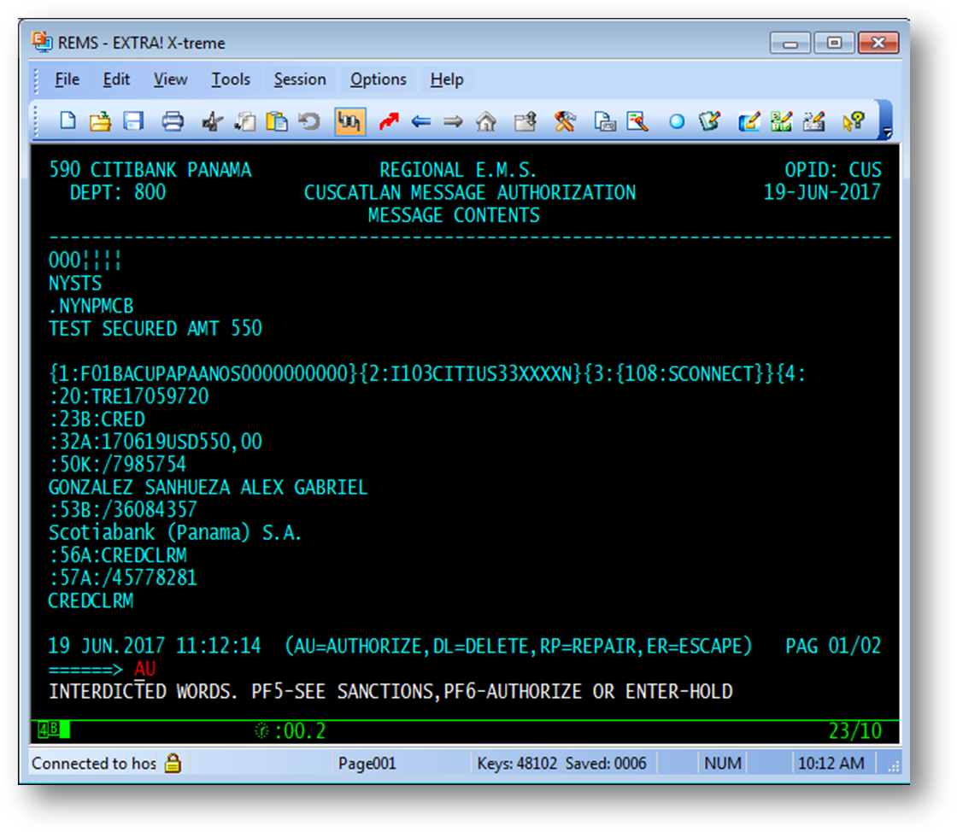

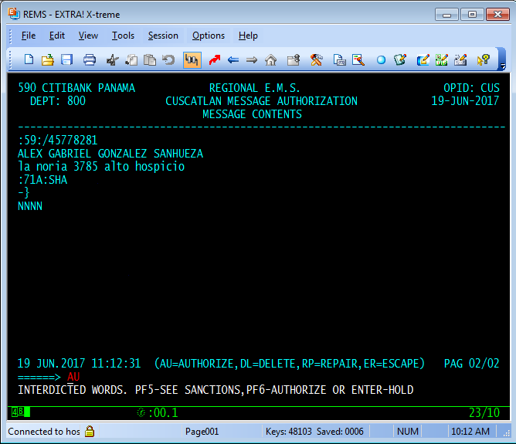

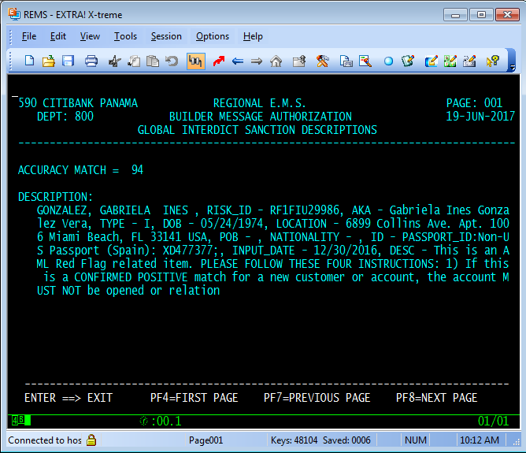

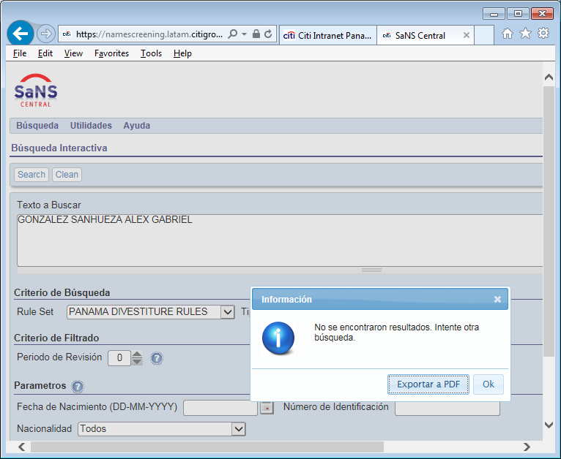

Guatemala:

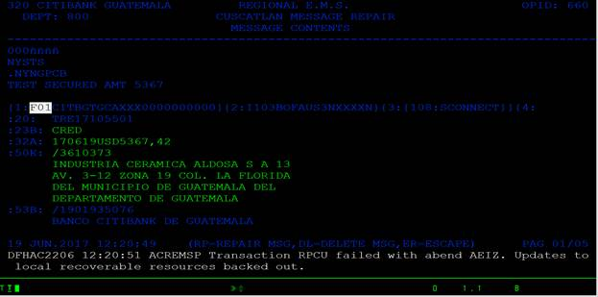

Nicaragua:

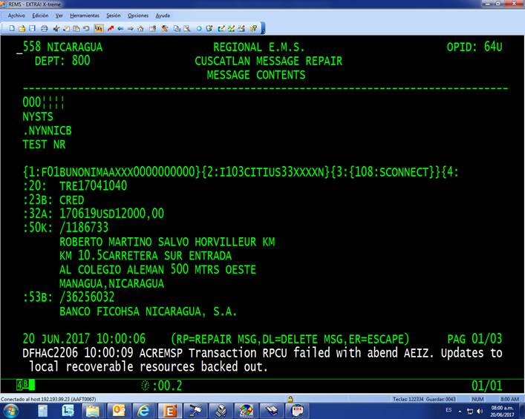

Ejemplo de porque se mandan a reparar:

“Karen, esta operación viajo correctamente a REMS, lo que necesitamos es modificar un error de mecanografía, una de las palabras está mal escrita y eso el que necesitamos corregir para esto el supervisor manda la gestión a un estado llamado RP que para repararla (corregirla) y el operador utiliza un comando llamado RPCU para proceder a corregirla”

**SOLUCIÓN: el equipo de REMS realizó roll back a su liberación, no consideraban que la gente usara la opción de reparación.**

El Salvador

MT940

* Interfaz: Swifttasks
* Logs a revisar:

\\10.233.53.149\Swifttasks\SwiftTask.log --> buscar por número de referencia proporcionado por el usuario que reporta o cuenta de usuario.

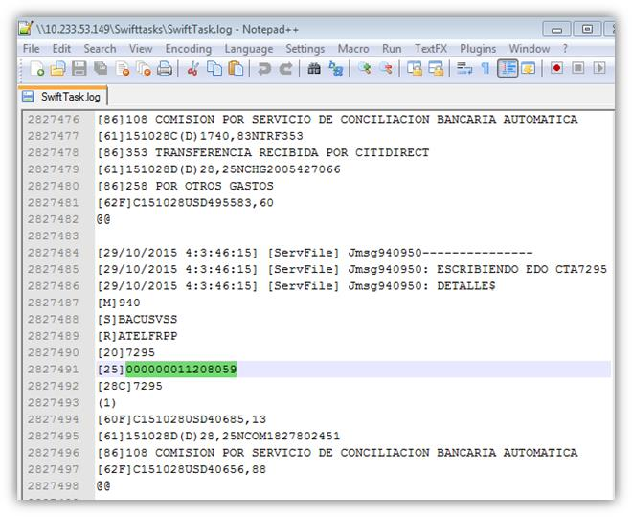

\\10.233.53.149\sconnect\CATEGORIA9\TO_SWIFT

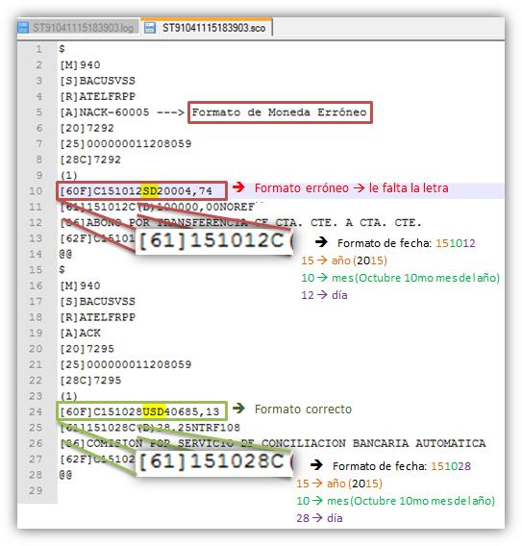

\\10.233.53.149\sconnect\CATEGORIA9\TO_SWIFT\Logs

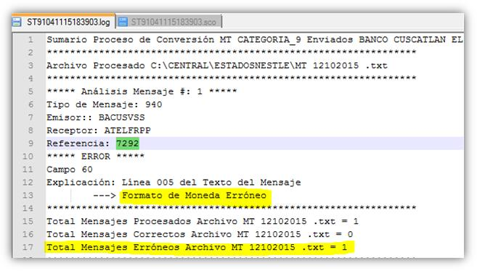

¿Cómo sé que si se enviaron?

\\10.233.53.149\RemsInterface\sent

Formato del nombre de los archivos: AAMMDDHHMM

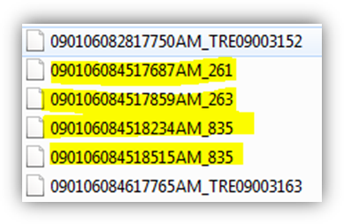

* Basta con solicitar que se reinicie la interface SwiftTask para que genere los archivos.
* Es la única interfaz que se ve afectada por el JBOSS. (Ruta de log: C:\jboss-4.0.2\server\default\log)
* Para volver a mandar un MT940 en específico se debe poner el archivo en la ruta: 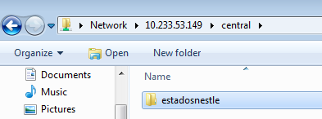

tipos de incidentes

* **NO SE ENVIARON LOS MT940**

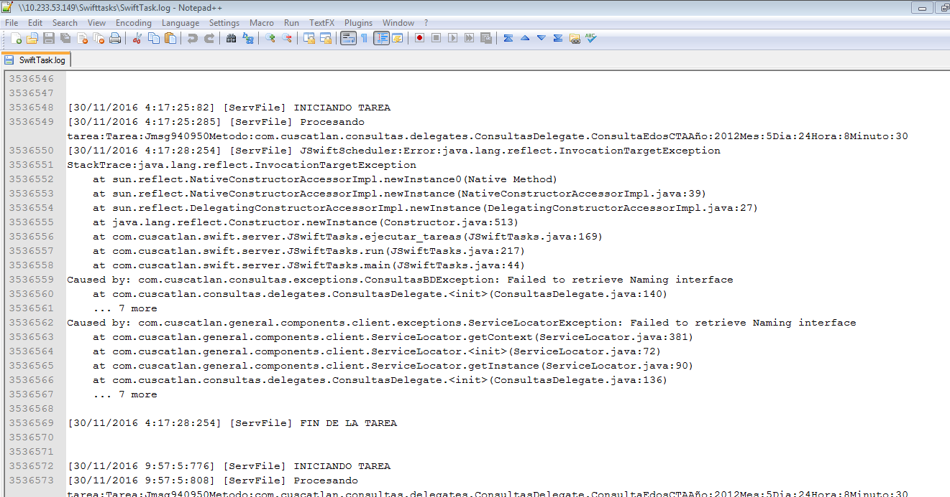

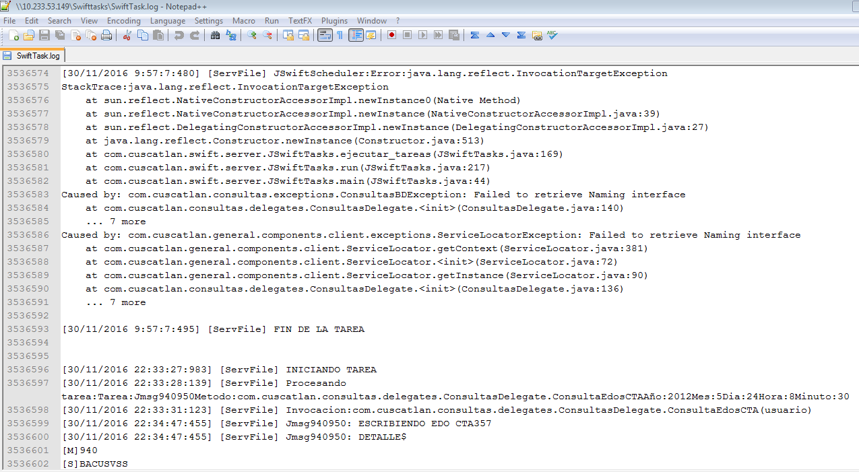

Log en JBOSS

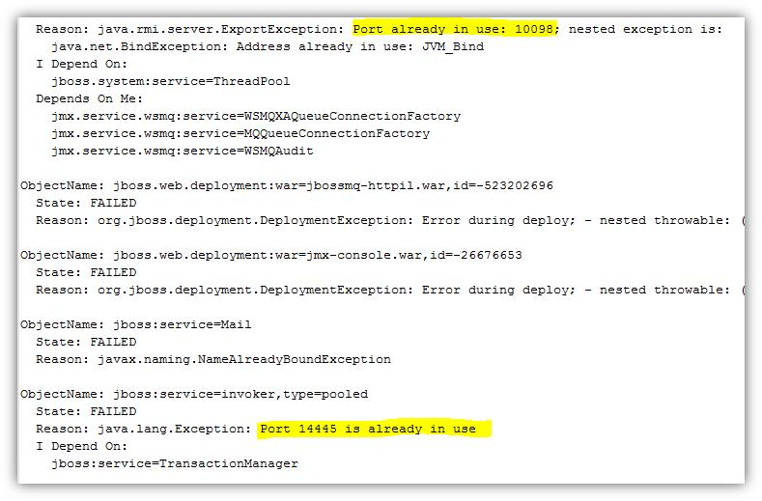

* **CLIENTE REPORTA QUE NO LE LLEGAN LOS MT940**

Si el cliente tiene el código BIC diferente implica que un tercero le brinda el acceso a consultar sus MT940 (estados de cuenta diarios), por lo que si aparece en la carpeta de enviados del remsinterface hasta ahí queda el camino que podemos validar de nuestro lado, de ahí es que consulten con el tercero en cuestión por los MT940.

Si aparece ahí y el cliente sigue reportando que no le llego hay que validar el código BIC ([R]):

* + Revisar en los logs, que aparezcan los MT940 del cliente que reportan.
  + Si aparecen hay que validar si se mandó a NY (solo aplica a los BIC: CITIGB2LIFP - CITIUS33)
    - Crear Marketplace por mensaje a consultar: [https://cmp.nj.ssmb.com/marketplace/control/product/~productId=45759_98424_GLOBAL#](https://cmp.nj.ssmb.com/marketplace/control/product/~productId=45759_98424_GLOBAL)
  + Consultar con Ricardo Lima para confirmar si llego a Londres:

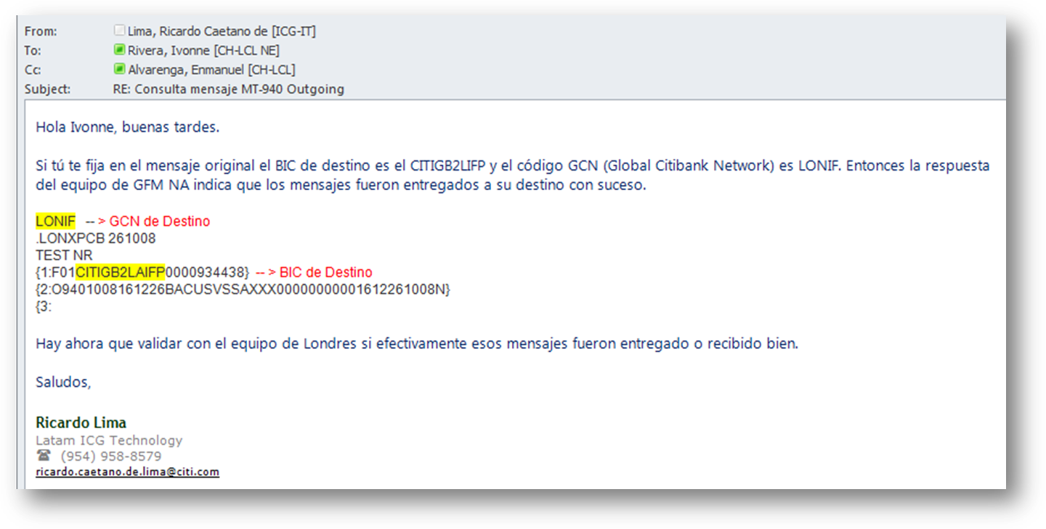

* **CASO CLIENTE CTE**

El incidente era que al cliente se le creaban los MT940 pero no se le enviaban.

Causa: Descuadre de saldos finales en los encabezados debido a causas cobis repetidas.

Solución: Corregir las causas cobis.

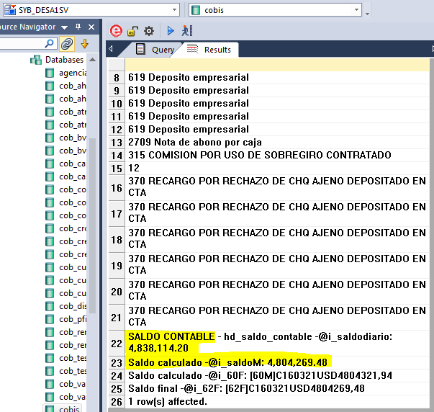



* **CASO TAG DE CIERRE**

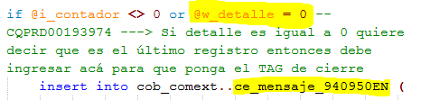

|  |  |  |  |  |  |  |  |  |  |  |  |  |  |  |  |  |  |  |  |  |  |  |  |  |  |  |  |  |  |  |  |  |  |  |  |  |  |  |  |  |  |  |  |  |  |  |  |  |  |  |  |  |  |  |  |  |  |  |  |  |  |  |  |  |  |  |  |  |  |  |  |  |  |  |  |  |  |  |  |  |  |  |  |  |  |  |  |  |  |  |  |  |  |  |  |  |  |  |  |  |  |  |  |  |  |  |  |  |  |  |  |  |  |  |  |  |  |  |  |  |  |  |  |  |  |  |  |  |  |  |  |  |  |  |  |  |  |  |  |  |  |  |  |  |  |  |  |  |  |  |  |  |  |  |  |  |  |  |  |  |  |  |  |  |  |  |  |  |  |  |  |  |  |  |  |  |  |  |  |  |  |  |  |  |  |  |  |  |  |  |  |  |  |  |  |  |  |  |  |  |  |  |  |  |  |  |  |  |  |  |  |  |  |  |  |  |  |  |  |  |  |  |  |  |  |  |  |  |  |  |  |  |  |  |  |  |  |  |  |  |  |  |  |  |  |  |  |  |  |  |  |  |  |  |  |  |  |  |  |  |  |  |  |  |  |  |  |  |  |  |  |  |  |  |  |  |  |  |  |  |  |  |  |  |  |  |  |  |  |  |  |  |  |  |  |  |  |  |  |  |  |  |  |  |  |  |  |  |  |  |  |  |  |  |  |  |  |  |  |  |  |  |  |  |  |  |  |  |  |  |  |  |  |  |  |  |  |  |  |  |  |  |  |  |  |  |  |  |  |  |  |  |  |  |  |  |  |  |  |  |  |  |  |  |  |  |  |  |  |  |  |  |  |  |  |  |  |  |  |  |  |  |  |  |  |  |  |  |  |  |  |  |  |  |  |  |  |  |  |  |  |  |  |  |  |  |  |  |  |  |  |  |  |  |  |  |  |  |  |  |  |  |  |  |  |  |  |  |  |  |  |  |  |  |  |  |  |  |  |  |  |  |  |  |  |  |  |  |  |  |  |  |  |  |  |  |  |  |  |  |  |  |  |  |  |  |  |  |  |  |  |  |  |  |  |  |  |  |  |  |  |  |  |  |  |  |  |  |  |  |  |  |  |  |  |  |  |  |  |  |  |  |  |  |  |  |  |  |  |  |  |  |  |  |  |  |  |  |  |  |  |  |  |  |  |  |  |  |  |  |  |  |  |  |  |  |  |  |  |  |  |  |  |  |  |  |  |  |  |  |  |  |  |  |  |  |  |  |  |  |  |  |  |  |  |  |  |  |  |  |  |  |  |  |  |  |  |  |  |  |  |  |  |  |  |  |  |  |  |  |  |  |  |  |  |  |  |  |  |  |  |  |  |  |  |  |  |  |  |  |  |  |  |  |  |  |  |  |  |  |  |  |  |  |  |  |  |  |  |  |  |  |  |  |  |  |  |  |  |  |  |  |  |  |  |  |  |  |  |  |  |  |  |  |  |  |  |  |  |  |  |  |  |  |  |  |  |  |  |  |  |  |  |  |  |  |  |  |  |  |  |  |  |  |  |  |  |  |  |  |  |  |  |  |  |  |  |  |  |  |  |  |  |  |  |  |  |  |  |  |  |  |  |  |  |  |  |  |  |  |  |  |  |  |  |  |  |  |  |  |  |  |  |  |  |  |  |  |  |  |  |  |  |  |  |  |  |  |  |  |  |  |  |  |  |  |  |  |  |  |  |  |  |  |  |  |  |  |  |  |  |  |  |  |  |  |  |  |  |  |  |  |  |  |  |  |  |  |  |  |  |  |  |  |  |  |  |  |  |  |  |  |  |  |  |  |  |  |  |  |  |  |  |  |  |  |  |  |  |  |  |  |  |  |  |  |  |  |  |  |  |  |  |  |  |  |  |  |  |  |  |  |  |  |  |  |  |  |  |  |  |  |  |  |  |  |  |  |  |  |  |  |  |  |  |  |  |  |  |  |  |  |  |  |  |  |  |  |  |  |  |  |  |  |  |  |  |  |  |  |  |  |  |  |  |  |  |  |  |  |  |  |  |  |  |  |  |  |  |  |  |  |  |  |  |  |  |  |  |  |  |  |  |  |  |  |  |  |  |  |  |  |  |  |  |  |  |  |  |  |  |  |  |  |  |  |  |  |  |  |  |  |  |  |  |  |  |  |  |  |  |  |  |  |  |  |  |  |  |  |  |  |  |  |  |  |  |  |  |  |  |  |  |  |  |  |  |  |  |  |  |  |  |  |  |  |  |  |  |  |  |  |  |  |  |  |  |  |  |  |  |  |  |  |  |  |  |  |  |  |  |  |  |  |  |  |  |  |  |  |  |  |  |  |  |  |  |  |  |  |  |  |  |  |  |  |  |  |  |  |  |  |  |  |  |  |  |  |  |  |  |  |  |  |  |  |  |  |  |  |  |  |  |  |  |  |  |  |  |  |  |  |  |  |  |  |  |  |  |  |  |  |  |  |  |  |  |  |  |  |  |  |  |  |  |  |  |  |  |  |  |  |  |  |  |  |  |  |  |  |  |  |  |  |  |  |  |  |  |  |  |  |  |  |  |  |  |  |  |  |  |  |  |  |  |  |  |  |  |  |  |  |  |  |  |  |  |  |  |  |  |  |  |  |  |  |  |  |  |  |  |  |  |  |  |  |  |  |  |  |  |  |  |  |  |  |  |  |  |  |  |  |  |  |  |  |  |  |  |  |  |  |  |  |  |  |  |  |  |  |  |  |  |  |  |  |  |  |  |  |  |  |  |  |  |  |  |  |  |  |  |  |  |  |  |  |  |  |  |  |  |  |  |  |  |  |  |  |  |  |  |  |  |  |  |  |  |  |  |  |  |  |  |  |  |  |  |  |  |  |  |  |  |  |  |  |  |  |  |  |  |  |  |  |  |  |  |  |  |  |  |  |  |  |  |  |  |  |  |  |  |  |  |  |  |  |  |  |  |  |  |  |  |  |  |  |  |  |  |  |  |  |  |  |  |  |  |  |  |  |  |  |  |  |  |  |  |  |  |  |  |  |  |  |  |  |  |  |  |  |  |  |  |  |  |  |  |  |  |  |  |  |  |
| --- | --- | --- | --- | --- | --- | --- | --- | --- | --- | --- | --- | --- | --- | --- | --- | --- | --- | --- | --- | --- | --- | --- | --- | --- | --- | --- | --- | --- | --- | --- | --- | --- | --- | --- | --- | --- | --- | --- | --- | --- | --- | --- | --- | --- | --- | --- | --- | --- | --- | --- | --- | --- | --- | --- | --- | --- | --- | --- | --- | --- | --- | --- | --- | --- | --- | --- | --- | --- | --- | --- | --- | --- | --- | --- | --- | --- | --- | --- | --- | --- | --- | --- | --- | --- | --- | --- | --- | --- | --- | --- | --- | --- | --- | --- | --- | --- | --- | --- | --- | --- | --- | --- | --- | --- | --- | --- | --- | --- | --- | --- | --- | --- | --- | --- | --- | --- | --- | --- | --- | --- | --- | --- | --- | --- | --- | --- | --- | --- | --- | --- | --- | --- | --- | --- | --- | --- | --- | --- | --- | --- | --- | --- | --- | --- | --- | --- | --- | --- | --- | --- | --- | --- | --- | --- | --- | --- | --- | --- | --- | --- | --- | --- | --- | --- | --- | --- | --- | --- | --- | --- | --- | --- | --- | --- | --- | --- | --- | --- | --- | --- | --- | --- | --- | --- | --- | --- | --- | --- | --- | --- | --- | --- | --- | --- | --- | --- | --- | --- | --- | --- | --- | --- | --- | --- | --- | --- | --- | --- | --- | --- | --- | --- | --- | --- | --- | --- | --- | --- | --- | --- | --- | --- | --- | --- | --- | --- | --- | --- | --- | --- | --- | --- | --- | --- | --- | --- | --- | --- | --- | --- | --- | --- | --- | --- | --- | --- | --- | --- | --- | --- | --- | --- | --- | --- | --- | --- | --- | --- | --- | --- | --- | --- | --- | --- | --- | --- | --- | --- | --- | --- | --- | --- | --- | --- | --- | --- | --- | --- | --- | --- | --- | --- | --- | --- | --- | --- | --- | --- | --- | --- | --- | --- | --- | --- | --- | --- | --- | --- | --- | --- | --- | --- | --- | --- | --- | --- | --- | --- | --- | --- | --- | --- | --- | --- | --- | --- | --- | --- | --- | --- | --- | --- | --- | --- | --- | --- | --- | --- | --- | --- | --- | --- | --- | --- | --- | --- | --- | --- | --- | --- | --- | --- | --- | --- | --- | --- | --- | --- | --- | --- | --- | --- | --- | --- | --- | --- | --- | --- | --- | --- | --- | --- | --- | --- | --- | --- | --- | --- | --- | --- | --- | --- | --- | --- | --- | --- | --- | --- | --- | --- | --- | --- | --- | --- | --- | --- | --- | --- | --- | --- | --- | --- | --- | --- | --- | --- | --- | --- | --- | --- | --- | --- | --- | --- | --- | --- | --- | --- | --- | --- | --- | --- | --- | --- | --- | --- | --- | --- | --- | --- | --- | --- | --- | --- | --- | --- | --- | --- | --- | --- | --- | --- | --- | --- | --- | --- | --- | --- | --- | --- | --- | --- | --- | --- | --- | --- | --- | --- | --- | --- | --- | --- | --- | --- | --- | --- | --- | --- | --- | --- | --- | --- | --- | --- | --- | --- | --- | --- | --- | --- | --- | --- | --- | --- | --- | --- | --- | --- | --- | --- | --- | --- | --- | --- | --- | --- | --- | --- | --- | --- | --- | --- | --- | --- | --- | --- | --- | --- | --- | --- | --- | --- | --- | --- | --- | --- | --- | --- | --- | --- | --- | --- | --- | --- | --- | --- | --- | --- | --- | --- | --- | --- | --- | --- | --- | --- | --- | --- | --- | --- | --- | --- | --- | --- | --- | --- | --- | --- | --- | --- | --- | --- | --- | --- | --- | --- | --- | --- | --- | --- | --- | --- | --- | --- | --- | --- | --- | --- | --- | --- | --- | --- | --- | --- | --- | --- | --- | --- | --- | --- | --- | --- | --- | --- | --- | --- | --- | --- | --- | --- | --- | --- | --- | --- | --- | --- | --- | --- | --- | --- | --- | --- | --- | --- | --- | --- | --- | --- | --- | --- | --- | --- | --- | --- | --- | --- | --- | --- | --- | --- | --- | --- | --- | --- | --- | --- | --- | --- | --- | --- | --- | --- | --- | --- | --- | --- | --- | --- | --- | --- | --- | --- | --- | --- | --- | --- | --- | --- | --- | --- | --- | --- | --- | --- | --- | --- | --- | --- | --- | --- | --- | --- | --- | --- | --- | --- | --- | --- | --- | --- | --- | --- | --- | --- | --- | --- | --- | --- | --- | --- | --- | --- | --- | --- | --- | --- | --- | --- | --- | --- | --- | --- | --- | --- | --- | --- | --- | --- | --- | --- | --- | --- | --- | --- | --- | --- | --- | --- | --- | --- | --- | --- | --- | --- | --- | --- | --- | --- | --- | --- | --- | --- | --- | --- | --- | --- | --- | --- | --- | --- | --- | --- | --- | --- | --- | --- | --- | --- | --- | --- | --- | --- | --- | --- | --- | --- | --- | --- | --- | --- | --- | --- | --- | --- | --- | --- | --- | --- | --- | --- | --- | --- | --- | --- | --- | --- | --- | --- | --- | --- | --- | --- | --- | --- | --- | --- | --- | --- | --- | --- | --- | --- | --- | --- | --- | --- | --- | --- | --- | --- | --- | --- | --- | --- | --- | --- | --- | --- | --- | --- | --- | --- | --- | --- | --- | --- | --- | --- | --- | --- | --- | --- | --- | --- | --- | --- | --- | --- | --- | --- | --- | --- | --- | --- | --- | --- | --- | --- | --- | --- | --- | --- | --- | --- | --- | --- | --- | --- | --- | --- | --- | --- | --- | --- | --- | --- | --- | --- | --- | --- | --- | --- | --- | --- | --- | --- | --- | --- | --- | --- | --- | --- | --- | --- | --- | --- | --- | --- | --- | --- | --- | --- | --- | --- | --- | --- | --- | --- | --- | --- | --- | --- | --- | --- | --- | --- | --- | --- | --- | --- | --- | --- | --- | --- | --- | --- | --- | --- | --- | --- | --- | --- | --- | --- | --- | --- | --- | --- | --- | --- | --- | --- | --- | --- | --- | --- | --- | --- | --- | --- | --- | --- | --- | --- | --- | --- | --- | --- | --- | --- | --- | --- | --- | --- | --- | --- | --- | --- | --- | --- | --- | --- | --- | --- | --- | --- | --- | --- | --- | --- | --- | --- | --- | --- | --- | --- | --- | --- | --- | --- | --- | --- | --- | --- | --- | --- | --- | --- | --- | --- | --- | --- | --- | --- | --- | --- | --- | --- | --- | --- | --- | --- | --- | --- | --- | --- | --- | --- | --- | --- | --- | --- | --- | --- | --- | --- | --- | --- | --- | --- | --- | --- | --- | --- | --- | --- | --- | --- | --- | --- | --- | --- | --- | --- | --- | --- | --- | --- | --- | --- | --- | --- | --- | --- | --- | --- | --- | --- | --- | --- | --- | --- | --- | --- | --- | --- | --- | --- | --- | --- | --- | --- | --- | --- | --- | --- | --- | --- | --- | --- | --- | --- | --- | --- | --- | --- | --- | --- | --- | --- | --- | --- | --- | --- | --- | --- | --- | --- | --- | --- | --- | --- | --- | --- | --- | --- | --- | --- | --- | --- | --- | --- | --- | --- | --- | --- | --- | --- | --- | --- | --- | --- | --- | --- | --- | --- | --- | --- | --- | --- | --- | --- | --- | --- | --- | --- | --- | --- | --- | --- | --- | --- | --- | --- | --- | --- | --- | --- | --- | --- | --- | --- | --- | --- | --- | --- | --- | --- | --- | --- | --- | --- | --- | --- | --- | --- | --- | --- | --- | --- | --- | --- | --- | --- | --- | --- | --- | --- | --- | --- | --- | --- | --- | --- | --- | --- | --- | --- | --- | --- | --- | --- | --- | --- | --- | --- | --- | --- | --- | --- | --- | --- | --- | --- | --- | --- | --- | --- | --- | --- | --- | --- | --- | --- | --- | --- | --- | --- | --- | --- | --- | --- | --- | --- | --- | --- | --- | --- | --- | --- | --- | --- | --- | --- | --- | --- | --- | --- | --- | --- | --- | --- | --- | --- | --- | --- | --- | --- | --- | --- | --- | --- | --- | --- | --- | --- | --- | --- | --- | --- | --- | --- | --- | --- | --- | --- | --- | --- | --- | --- | --- | --- | --- | --- | --- | --- | --- | --- | --- | --- | --- | --- | --- | --- | --- | --- | --- | --- | --- | --- | --- | --- | --- | --- | --- | --- | --- | --- | --- | --- | --- | --- | --- | --- | --- | --- | --- | --- | --- | --- | --- | --- | --- | --- | --- | --- | --- | --- | --- | --- | --- | --- | --- | --- | --- | --- | --- | --- | --- | --- | --- | --- | --- | --- | --- | --- | --- | --- | --- | --- | --- | --- | --- | --- | --- | --- | --- | --- | --- | --- | --- | --- | --- | --- | --- | --- | --- | --- | --- | --- | --- | --- | --- | --- | --- | --- | --- | --- | --- | --- | --- | --- | --- | --- | --- | --- | --- | --- | --- | --- | --- | --- | --- | --- | --- | --- | --- | --- | --- | --- | --- | --- | --- | --- | --- | --- | --- | --- | --- | --- | --- | --- | --- |
| |  |  |  |  |  |  |  |  |  |  | | --- | --- | --- | --- | --- | --- | --- | --- | --- | --- | | **PRUEBAS DE QUE LOS CAMBIOS REALIZADOS BRINDAN EL RESULTADO ESPERADO** | | | |  |  |  |  |  |  | |  |  |  |  |  |  |  |  |  |  | | Prueba con registros distinto a 20 el cual no presentaba el problema: |  |  | me_mensaje = cantidad de registros por página | |  |  |  |  |  | |  |  |  |  |  |  |  |  |  |  | | **Caso de cuenta corriente:** |  |  |  |  |  |  |  |  |  | |  |  |  |  |  |  |  |  |  |  | | Ejecución con sp original: |  |  |  |  |  |  |  |  |  | | |  | | --- | |  | |  |  |  |  |  |  |  |  |  | |  |  |  |  |  |  |  |  |  |  | |  |  |  |  |  |  |  |  |  |  | |  |  |  |  |  |  |  |  |  |  | |  |  |  |  |  |  |  |  |  |  | |  |  |  |  |  |  |  |  |  |  | |  |  |  |  |  |  |  |  |  |  | |  |  |  |  |  |  |  |  |  |  | |  |  |  |  |  |  |  |  |  |  | |  |  |  |  |  |  |  |  |  |  | |  |  |  |  |  |  |  |  |  |  | |  |  |  |  |  |  |  |  |  |  | |  |  |  |  |  |  |  |  |  |  | |  |  |  |  |  |  |  |  |  |  | |  |  |  |  |  |  |  |  |  |  | |  |  |  |  |  |  |  |  |  |  | |  |  |  |  |  |  |  |  |  |  | |  |  |  |  |  |  |  |  |  |  | |  |  |  |  |  |  |  |  |  |  | |  |  |  |  |  |  |  |  |  |  | |  |  |  |  |  |  |  |  |  |  | | Ejecución con sp modificado: |  |  |  |  |  |  |  |  |  | |  |  |  |  |  |  |  |  |  |  | | |  | | --- | |  | |  |  |  |  |  |  |  |  |  | |  |  |  |  |  |  |  |  |  |  | |  |  |  |  |  |  |  |  |  |  | |  |  |  |  |  |  |  |  |  |  | |  |  |  |  |  |  |  |  |  |  | |  |  |  |  |  |  |  |  |  |  | |  |  |  |  |  |  |  |  |  |  | |  |  |  |  |  |  |  |  |  |  | |  |  |  |  |  |  |  |  |  |  | |  |  |  |  |  |  |  |  |  |  | |  |  |  |  |  |  |  |  |  |  | |  |  |  |  |  |  |  |  |  |  | |  |  |  |  |  |  |  |  |  |  | |  |  |  |  |  |  |  |  |  |  | |  |  |  |  |  |  |  |  |  |  | |  |  |  |  |  |  |  |  |  |  | |  |  |  |  |  |  |  |  |  |  | |  |  |  |  |  |  |  |  |  |  | |  |  |  |  |  |  |  |  |  |  | |  |  |  |  |  |  |  |  |  |  | | **Caso de cuenta de ahorro:** |  |  |  |  |  |  |  |  |  | |  |  |  |  |  |  |  |  |  |  | | Ejecución con sp original: |  |  |  |  |  |  |  |  |  | | |  | | --- | |  | |  |  |  |  |  |  |  |  |  | |  |  |  |  |  |  |  |  |  |  | |  |  |  |  |  |  |  |  |  |  | |  |  |  |  |  |  |  |  |  |  | |  |  |  |  |  |  |  |  |  |  | |  |  |  |  |  |  |  |  |  |  | |  |  |  |  |  |  |  |  |  |  | |  |  |  |  |  |  |  |  |  |  | | Ejecución con sp modificado: |  |  |  |  |  |  |  |  |  | | |  | | --- | |  | |  |  |  |  |  |  |  |  |  | |  |  |  |  |  |  |  |  |  |  | |  |  |  |  |  |  |  |  |  |  | |  |  |  |  |  |  |  |  |  |  | |  |  |  |  |  |  |  |  |  |  | |  |  |  |  |  |  |  |  |  |  | |  |  |  |  |  |  |  |  |  |  | | Prueba con registros divisibles entre 20 el cual presentaba el problema: |  |  |  |  |  |  |  |  |  | |  |  |  | me_mensaje = cantidad de registros por página | |  |  |  |  |  | | **Caso de cuenta corriente:** |  |  |  |  |  |  |  |  |  | |  |  |  |  |  |  |  |  |  |  | | Ejecución con sp original: |  |  |  |  |  |  |  |  |  | | |  | | --- | |  | |  |  |  |  |  |  |  |  |  | |  |  |  |  |  |  |  |  |  |  | |  |  |  |  |  |  |  |  |  |  | |  |  |  |  |  |  |  |  |  |  | |  |  |  |  |  |  |  |  |  |  | |  |  |  |  |  |  |  |  |  |  | |  |  |  |  |  |  |  |  |  |  | |  |  |  |  |  |  |  |  |  |  | |  |  |  |  |  |  |  |  |  |  | |  |  |  |  |  |  |  |  |  |  | |  |  |  |  |  |  |  |  |  |  | |  |  |  |  |  |  |  |  |  |  | |  |  |  |  |  |  |  |  |  |  | |  |  |  |  |  |  |  |  |  |  | |  |  |  |  |  |  |  |  |  |  | |  |  |  |  |  |  |  |  |  |  | |  |  |  |  |  |  |  |  |  |  | |  |  |  |  |  |  |  |  |  |  | |  |  |  |  |  |  |  |  |  |  | | Ejecución con sp modificado: |  |  |  |  |  |  |  |  |  | | |  | | --- | |  | |  |  |  |  |  |  |  |  |  | |  |  |  |  |  |  |  |  |  |  | |  |  |  |  |  |  |  |  |  |  | |  |  |  |  |  |  |  |  |  |  | |  |  |  |  |  |  |  |  |  |  | |  |  |  |  |  |  |  |  |  |  | |  |  |  |  |  |  |  |  |  |  | |  |  |  |  |  |  |  |  |  |  | |  |  |  |  |  |  |  |  |  |  | |  |  |  |  |  |  |  |  |  |  | |  |  |  |  |  |  |  |  |  |  | |  |  |  |  |  |  |  |  |  |  | |  |  |  |  |  |  |  |  |  |  | |  |  |  |  |  |  |  |  |  |  | |  |  |  |  |  |  |  |  |  |  | |  |  |  |  |  |  |  |  |  |  | |  |  |  |  |  |  |  |  |  |  | |  |  |  |  |  |  |  |  |  |  | |  |  |  |  |  |  |  |  |  |  | |  |  |  |  |  |  |  |  |  |  | |  |  |  |  |  |  |  |  |  |  | |  |  |  |  |  |  |  |  |  |  | |  |  |  |  |  |  |  |  |  |  | | **Caso de cuenta de ahorro:** |  |  |  |  |  |  |  |  |  | |  |  |  |  |  |  |  |  |  |  | | Ejecución con sp original: |  |  |  |  |  |  |  |  |  | | |  | | --- | |  | |  |  |  |  |  |  |  |  |  | |  |  |  |  |  |  |  |  |  |  | |  |  |  |  |  |  |  |  |  |  | |  |  |  |  |  |  |  |  |  |  | |  |  |  |  |  |  |  |  |  |  | |  |  |  |  |  |  |  |  |  |  | |  |  |  |  |  |  |  |  |  |  | | Ejecución con sp modificado: |  |  |  |  |  |  |  |  |  | | |  | | --- | |  | |  |  |  |  |  |  |  |  |  | |  |  |  |  |  |  |  |  |  |  | |  |  |  |  |  |  |  |  |  |  | |  |  |  |  |  |  |  |  |  |  | |  |  |  |  |  |  |  |  |  |  | |  |  |  |  |  |  |  |  |  |  | |  |  |  |  |  |  |  |  |  |  |  |  |  |  |  |

TABLAS:

* **cob_comext..ce_mensaje_940950EN**🡪 Encabezado de cada página del MT940 (Si al finalizar no hace match los saldos, este se elimina y solo queda en la base el detalle de los movimientos)
* **cob_comext..ce_mensaje_det_940950EN** 🡪 aquí está el detalle de los movimientos de los MT940.
* ***cob_ahorros_his..ah_his_movimiento*** 🡪 aquí está el detalle de los movimientos de las cuentas.
* ***cob_comext..ce_mensaje940_swift_causacobis*** 🡪 aquí están las causas de los movimientos de los MT940, da error si los usuarios ingresan una causa con algún carácter especial.

MT101 – Embajada de los EEUU

Aquí se encuentran los mensajes con los pagos de la embajada:

\\10.233.53.149\central$\embajada_bck

Se realicen o no.

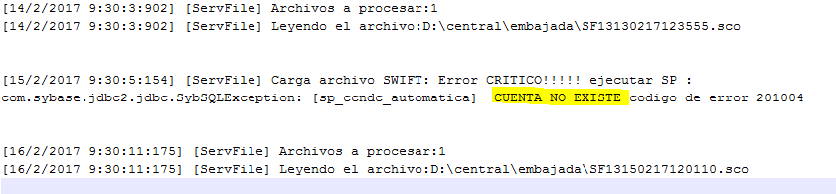

Buscar errores en el log:

\\10.233.53.149\filetran\swift.log

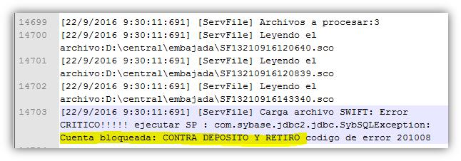

Tablas:

* cob_comext..ce_mensaje_101 – Pagos a cuentas propias del banco
* cob_comext..ce_interbanks_101– Pago a cuentas de otros bancos(Interbancarias)
* cob_comext..ce_mensaje_101_his

Carpetas:

* \\10.233.53.149\sconnect\CATEGORIA1\FROM_SWIFT\Procesados -- > Los archivos con nombre CFSC son los de la embajada.
* \\10.233.53.149\sconnect\CATEGORIA1\FROM_SWIFT\

Log:

* \\10.233.53.149\filetran\swift.log

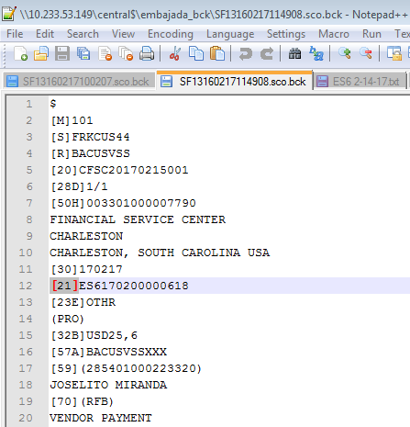

[21] – Es el identificador de pagos, si cuento cuantos hay de estos en el archivo obtengo cuantos pagos vienen en este.

[30] – Me indica la fecha en la que se debe ejecutar el pago. AÑOMESDIA

Si quisiera enviar yo los mensajes se puede hacer lo siguiente:

1. Copiar los archivos con los pagos de la carpeta **embajada** y obligar por medio de MW que se ejecute la tarea programada (JArchivo101) de la embajada de forma forzada. CUIDADO DE DUPLICAR

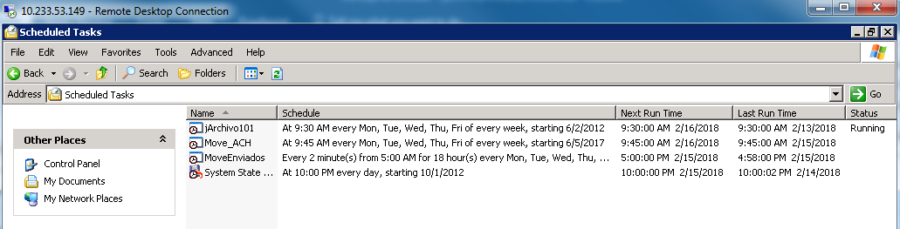

*** Log de las tareas programadas: SchedLgU.Txt – pesa máximo 32 KB luego empieza a sobre escribirse, su ubicación debe ser C:\Windows\

1. Se pueden hacer manualmente por parte del negocio. 🡪 **Siempre se prefiere esta opción.**

**Los archivos de ACH se pasan por medio del bat:**

***\\10.233.53.149\filetran\achmove.bat***

**Este la copia de la ruta:**

move /Y "\\10.233.53.149\D$\central\achfinal\*.*" "\\10.235.57.209\d$\ARCHIVOS_ACH\ARCHIVOS DE NBJ" >> \\10.233.53.149\D$\central\ach\%yy%\%mm%\achmt-%yy%-%mm%-%dd%.txt

1. **En caso de que la operación no haya detectado coincidencia entre GI(CITI) y SENTINEL(CUSCATLAN), entonces la operación queda lista para ser liberada para el día hábil siguiente.**
2. **En TADMIN/COBIS, se verifica el débito efectuado.**
3. **Se toma archivo de carpeta asignada en servidor compartido(**ARCHIVOS DE NBJ 🡪 el archivo formato java, para poder ser convertido a formato NACHA y poder enviarlo para su distribución a ACH)**, por medio de aplicativo PAYBANK, para luego ser retomado por aplicativo de PAYSWITCH, para su correspondiente envío.-**

**Carpetas de ACH:**

**\\10.233.53.149\central$\ach**

**\\10.233.53.149\central$\achfinal**

**\\10.233.53.149\central$\achfinal_bck**

Nicaragua

MT940

* Único lugar donde validar: \\10.233.56.25\RemsInterface\sent
* Si los MT940 no llegaron se puede solicitar el log por medio de ticket a MW:

Servidor WAS-1: ***LACSLVPIPPAS011 10.233.53.143***

Ruta: ***/opt/WebSphere/v700-64/profiles/AppESB01/logs/server1_esb/*** MT940Interface.log

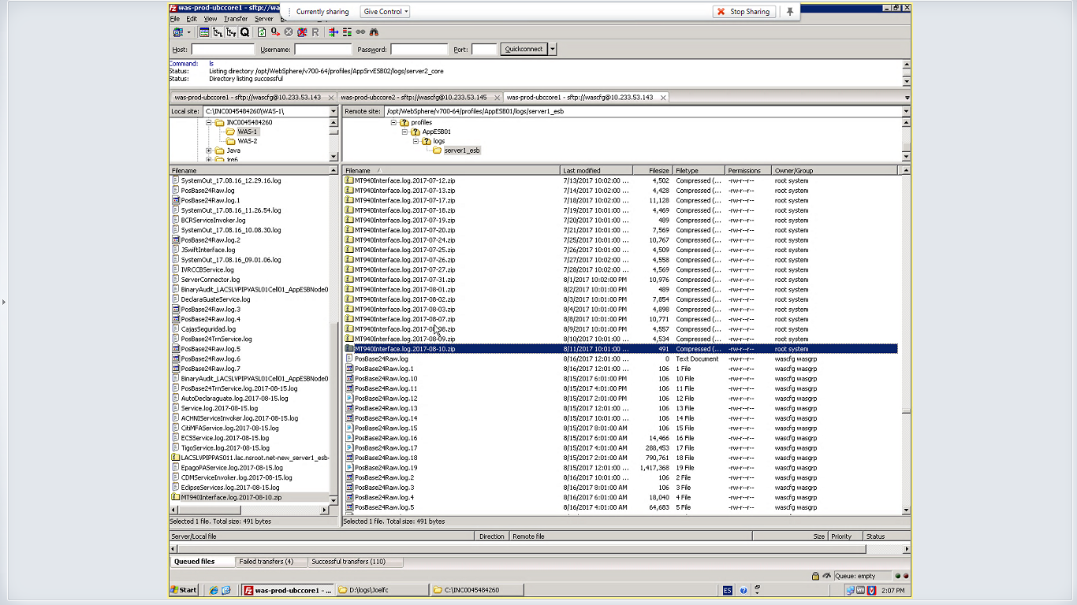

¿Cómo utilizar Contingencia del MT940 en Nicaragua?

Los usuarios ingresan al módulo y autorizan los MT940 y luego se solicita a MW ejecutar la contingencia, tomar en cuenta colocar el nombre del servidor 10.233.56.25 LACNICPESER001 y el proceso adecuado a ejecutar.

La ruta del BATCH para ejecutar el proceso de “MT940 Contingencia” está ubicada dentro de la ruta c:\Contingencia.

REENVIAR MT940

Copiar archivo del MT940 que se quiere reenviar de la siguiente ruta:

\\10.233.56.25\RemsInterface\sent

Copiar archivo con extensión .rje en la siguiente ruta:

\\10.233.56.25\central\estadosnestle

Conseguir aprobación del SCOO.

* El MT940 de Nicaragua trabaja de lunes a viernes, los mensajes que se manden el fin de semana serán enviados hasta el día lunes, claro que si éste no es un día identificado como feriado en cobis.
* Si un día queda con error el sistema volverá a intentar enviar los mensajes de ese día en su siguiente día hábil.

Hacer cambio de horario en interface del MT940

Ticket de referencia: INC0048291777

Cambio de hora de envío de MT940 Nicaragua

Pasos a seguir:

1. Detener la interfaz "MT940InterfaceEJBClient.EXE.bat" que debe estar corriendo en la sesión 0 del servidor.

2. Copiar el archivo C:\cliente\MT940InterfaceEJBClient.jar y descomprimirlo.

3. En la carpeta: \config\local modificar el archivo; "config.properties"

4. Substituir toda la información del archivo por la siguiente:

#TASK

task.cronExpression=0 30 11 ? * 2-6

5. Guardar los cambios.

6. En la carpeta config\production modificar de igual manera el archivo: "config.properties"

7. Subtituir toda la información del archivo por la siguiente:

#TASK

task.cronExpression=0 30 11 ? * 2-6

8.Guardar los cambios.

9. Generar un archivo comprimido con todas las carpetas extraidas del archivo JAR del paso 2 y renombrarlo a MT940InterfaceEJBClient.jar -- considerer el cambio de extension de .zip a .jar dado que es muy importante.

9. Iniciar la interfaz "MT940InterfaceEJBClient.EXE.bat" que debe quedar corriendo en la sesión 0 del servidor.

Se adjunta aprobación de Carlos Guevara.

Transferencias internacionales

|  |  |  |  |  |
| --- | --- | --- | --- | --- |
| PRODUCTO | PAIS |  | LOGS | Paso SCONNECT?? |
| TRE | EL SALVADOR | Netbanking | \\10.233.53.149\RemsInterface\log\RemsInterface.log  \\10.233.53.149\filetran\server.log  Errores acá: \\10.233.53.149\interfaces\mensaje103\server.log | \\10.233.53.149\RemsInterface\sent |
| CBOL | JmsgwrtJFPSV  \\10.233.53.149\sconnect\CATEGORIA1\TO_SWIFT\Logs |  |
| NICARAGUA | Netbanking | \\10.233.56.25\RemsInterface\log\RemsInterface.log  \\10.233.56.25\interfaces_nbj\Jmsgwrt103.log | \\10.233.56.25\RemsInterface\sent |
| CBOL | \\10.233.56.25\JmsgwrtJFPNI\jfp.log |  |
| COSTA RICA | Netbanking | \\10.233.77.77\RemsInterface\log  \\10.233.77.77\sconnect\CATEGORIA1\TO_SWIFT\Logs  \\10.233.77.77\interfaces_nbj\server.log  \\10.233.77.77\filetran_nbj\server.log | \\10.233.77.77\RemsInterface\sent |
| CBOL | \\10.233.77.77\JmsgwrtJFPCR |  |
| PANAMÁ | Netbanking | \\10.233.61.101\interfaces_nbj\Jmsgwrt103.log  \\10.233.61.101\sconnect\CATEGORIA1\TO_SWIFT\LOGS | \\10.233.61.101\Remsinterfase\sent |
| CBOL | \\10.233.61.101\JmsgwrtJFPPA\jfp.log |  |
| TRR | EL SALVADOR |  | **\\10.233.53.149\RemsInterface\log\RemsInterface.log**-- Acá aparecen como INCOMING MESSAGE solo si dio error.  \\10.233.53.149\sconnect\CATEGORIA1\FROM_SWIFT\Logs  \\10.233.53.149\directorioErr | \\10.233.53.149\central$\recibidos_bck |
| NICARAGUA | \\10.233.56.25\filetran_nbj\server.log  \\10.233.56.25\sconnect\CATEGORIA1\FROM_SWIFT\Logs | \\10.233.56.25\central\recibidos_bck |
| COSTA RICA | \\10.233.77.77\filetran_nbj\server.log -- aparecen recibidas  \\10.233.77.77\sconnect\CATEGORIA1\FROM_SWIFT\Logs  \\10.233.77.77\directorioErr | \\10.233.77.77\central\recibidos_bck |
| PANAMÁ | \\10.233.61.101\filetran_nbj\JArchivo.log  \\10.233.61.101\sconnect\CATEGORIA1\FROM_SWIFT\LOGS | \\10.233.61.101\Central\recibidos_bck |

# CBOL - Interfaz: jArchivo.bat

Siguiendo el camino de una TRE ingresada por módulo:

\\10.233.53.149\central$\enviados

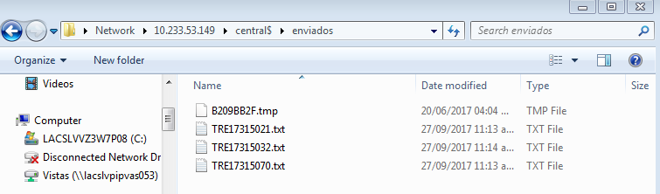

\\10.233.53.149\sconnect\CATEGORIA1\TO_SWIFT\Procesados

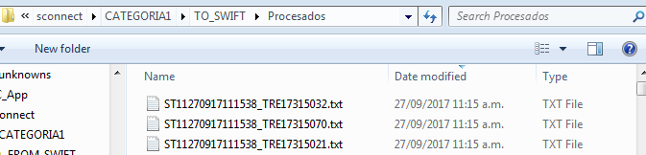

\\10.233.53.149\RemsInterface\log\RemsInterface.log

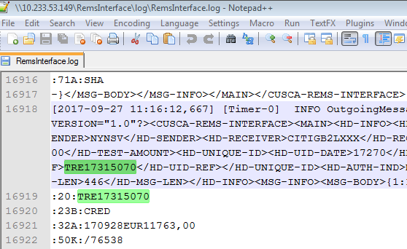

\\10.233.53.149\RemsInterface\sent

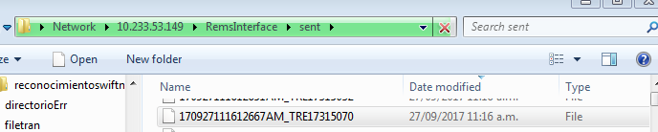

¿Cómo volver a mandar los mensajes que fallaron?

Recuerden!!! Se trabaja con dinero por lo que hay que tener cuidado con lo que se hace.

Una TRE aprobada no se puede revertir, solo se le puede pedir al corresponsal que no la aplique.

¿Cómo volver a mandar una TRR?

Ticket de ejemplo: INC0041417396

* Buscar mensajes por el número de referencia :20: en el log de RemsInteface. **\\10.233.53.149\RemsInterface\log\RemsInterface.log** **-- ACA APARECEN COMO INCOMING MESSAGE**

Archivo TRR enviada por el usuario:

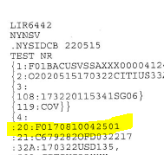

Búsqueda en el log:

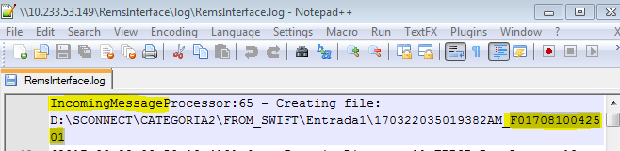

* Crear archivos sin extensión copiando desde **{1** hasta **{SAC}}**

**{1:F01BACUSVSSAXXX0000412439}{2:O2020515170322CITIUS33AXXX00000000001703220515N}{3:{108:173220115341SG06}{119:COV}}{4:**

**:20:F0170810042501**

**:21:C679282OFD032217**

**:32A:170322USD135,**

**:52A:CITIUS33XXX**

**:58A:BACUSVSS**

**:72:/INS/IADBUS3W**

**/BNF/IMAD 20170322B1Q8383C000562**

**:50K:/04025213**

**CASH MANAGEMENT SECTION - IDB**

**INTER-AMERICAN DEVELOPMENT BANK**

**1300 NEW YORK AVE, N.W.**

**WASHINGTON,DC 20577**

**:52A:IADBUS3W**

**:59:/024301000019741**

**LINEA EJECUTIVA S.A. DE C.V.**

**:70:/RFB/ATN-OC-15675-ESREQ 0005 O**

**PS0201710400A**

**:72:/INS/INTER AMERICAN DEVELOPMENT BAN**

**//K WASHINGTON, DC 20577 USA**

**:33B:USD135,**

**-}{5:{MAC:FFFFFFFF}{TAS:05150322}{SAC}}**

Uno por cada transferencia:

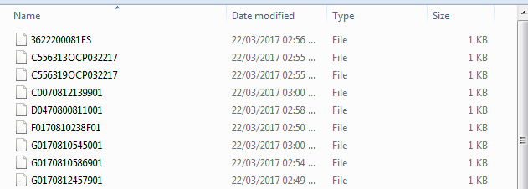

* Recordar dividir los mensajes por 103 y 202, esto se identifica en este campo del mensaje:

Una TRR 103 siempre puede tener o no tener un 202 asociado, pero una TRR 202 SIEMPRE tendrá un 103 asociado.

Las TRR 202 son las que están en espera de cobertura.

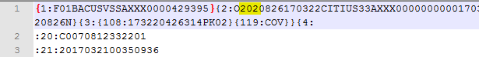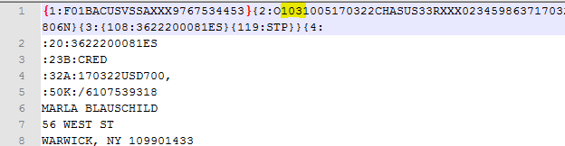

* Luego solicitar por ticket lo siguiente:

**Los archivos que se encuentran identificados en la carpeta 103, deben ser copiados a la siguiente ruta:**

**\\10.233.53.149\sconnect\CATEGORIA1\FROM_SWIFT\Entrada1**

**Los archivos que se encuentran identificados en la carpeta 202, deben ser copiados a la siguiente ruta:**

**\\10.233.53.149\sconnect\CATEGORIA2\FROM_SWIFT\Entrada1**

* Recordar solicitar aprobación de SCOO para que MW suba los archivos.

¿Cómo re-envío una TRE?

1ra forma.

Netbanking deja de mandar transferencias internacionales a la 1 de la tarde y las que lleguen se mandan al día siguiente.

Realizando una liberación:

update cob_comext..ce_mensaje_103_jfp

set me_32A = '151021'+substring(me_32A,7,30),

me_fecha = '10/21/2015'

where me_fecha = '10/15/2015'

and me_estado = 'P'

and me_referencia in ('TRE16000104', 'TRE16000411')

CONSIDERACIONES para las de netbanking:

DELETE cob_comext..ce_mensaje_103_nb_his

WHERE me_referencia in ('TRE15243611', 'TRE15243633', 'TRE15243644')

Go

IMPORTANTE:

Si no se borra la información en la tabla histórica de netbanking, la interfaz pasará todo el día con el error: ***“Attempt to insert duplicate key row in object 'ce_mensaje_103_nb_his' with unique index 'ce_mensaje_103_nb_his_idx'”*** y no enviará ni una TRE en todo el ese día.

2da forma.

1. Buscar los mensajes en:

\\10.233.53.149\RemsInterface\log\RemsInterface.log

\\10.233.53.149\JmsgwrtJFPSV\JmsgwrtJFP.log

\\10.233.53.149\interfaces\mensaje103\server.log

1. Crear un archivo como el siguiente, con extensión .txt:



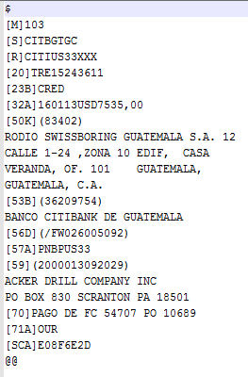

Validar que estén ingresadas en la base histórica:

Select * from cob_comext..ce_mensaje_103_jfp**_his**

2. Crear un ticket como el siguiente: INC0027959293

3. Adjuntar Visto bueno del SCOO o del negocio.

A donde deben poner los archivos:

* **\Central\enviados (pasan por la cola de autorizacion de los usuarios – estan las que se envian por medio del módulo de TRR y TRE)**
* **\Central\enviadosnet (pasan por la cola de autorizacion de los usuarios)** será enviado sin revisar por la interfaz.
* **D:\central\enviadosnet2\ (NO pasan por la cola de autorizacion de los usuarios)**

4. Revisar en la siguiente ruta para comprobar su envío: \\server\sconnect\CATEGORIA1\TO_SWIFT\Procesados

¿Cómo se si una transferencia entro a COBIS?

declare *@operacion_banco* char(14)

/* -- Ingresar aqui el codigo de la operacion banco --*/

select *@operacion_banco* = 'TRE09000103'

/* -------------------------------------------------- */

select * from **cob_comext..ce_operacion** where op_operacion_banco = *@operacion_banco*



|  |  |
| --- | --- |
| Op_etapa | Estados |
| 10 | Abierta |
| 11 | Procesada |
| 41 | Cerrada |
| 50 | Cancelada |

¿Cómo conocer de dónde procede una transferencia?

1ro. Buscar número de transferencia en \\server\sconnect\CATEGORIA1\TO_SWIFT\Procesados

2do. Buscar en el LOG: \\servidor\sconnect\CATEGORIA1\TO_SWIFT\Logs

3ro. Buscar en la parte de Archivo Procesado el nombre del archivo:

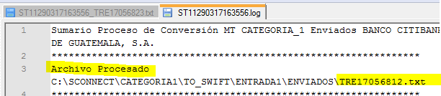

Para saber su procedencia nos basamos en el nombre del archivo:

|  |  |
| --- | --- |
| Empieza por | Procedencia |
| TRE… | Módulo |
| JF… | JFP |
| INT.. | NetBanking |

Entendiendo el formato de los mensajes

Plantillas TRE SV

CUSTOMER TRANSFER **MT - 100**

{1:F01 }{2:I }{4:

:20:SENDER'S REFERENCE

:32A:VALUE DATE/ CURRENCY CODE/ AMOUNT

:50:ORDERING CUSTOMER

:52A:ORDERING INSTITUTION

:53A:SENDER'S CORRESPONDENT

:54A:RECEIVER'S CORRESPONDENT

:56A:INTERMEDIARY

:57A:PAYEE BANK (OPTION A, B o D)

:59:BENEFICIARY CUSTOMER

:70:DETAILS OF PAYMENT

:71A:DETAILS OF CHARGES

:72:SENDER TO RECEIVER INFORMATION

TRANSFERENCIA ENVIADA **MT - 103**

{1:F01 .SS..SEQ..}{2:I }{4:

:20:REFERENCIA DEL EMISOR

:23B:CODIGO DE OPERACION DEL BANCO

:23E:CODIGO DE INSTRUCCION

:23E:CODIGO DE INSTRUCCION

:23E:CODIGO DE INSTRUCCION

:32A:FECHA (AAMMDD) / MONEDA / MONTO

:36:TASA DE CAMBIO

:50K:CLIENTE ORDENANTE (NOMBRE Y DIRECCION)

:52A:INSTITUCION AUTORIZADA

:53A:REFERENCIA DEL EMISOR

:54A:REFERENCIA DEL RECEPTOR

:56A:BANCO INTERMEDIARIO (OPCION A o D):

:57A:BANCO PAGADOR (OPCION A, B o D):

:59:BENEFICIARIO

:70:DETALLES DE PAGO

:71A:DETALLES DE GASTOS

:72:INFORMACION DE EMISOR A RECEPTOR

Explicación de terminología:

CCD 🡪 CARTA DE CREDITO DOMESTICA

CCE 🡪 CARTA DE CREDITO DE EXPORTACION

CCI 🡪 CARTAS DE CREDITOS DE IMPORTACION

CDE 🡪 COBRANZAS DE EXPORTACION

CDI 🡪 COBRANZAS DE IMPORTACIÓN

GRA 🡪 GARANTIA ADUANERA

GRB 🡪 GARANTIA BANCARIA

STB 🡪 CARTA DE CREDITO STAND BY

Estudiemos incidencias:



Consultar en la base de datos la tabla:

** cob_comext..ce_mensaje_103_nb_his ** - Ingresado por Netbanking Java

select * from cob_comext..ce_mensaje_103_nb_his

where me_referencia in ('TRE16161852')

go

Ver nombre del archivo generado para el mensaje en el campo:

|  |
| --- |
| **me_path** |
| D:\central\enviadosnet2\int_37377.txt |

Buscar archivo en: \\10.235.60.108\sconnect\CATEGORIA1\TO_SWIFT\Procesados

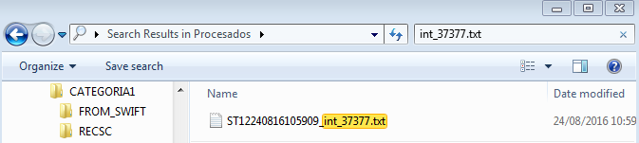

Buscar log del archivo utilizando la primera parte del nombre del archivo encontrado:

Ruta en donde buscar el log: \\10.235.60.108\sconnect\CATEGORIA1\TO_SWIFT\Logs

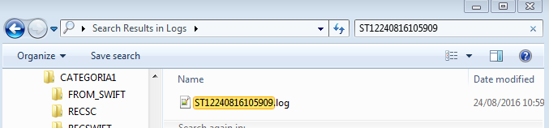

Encontramos el mensaje de error:

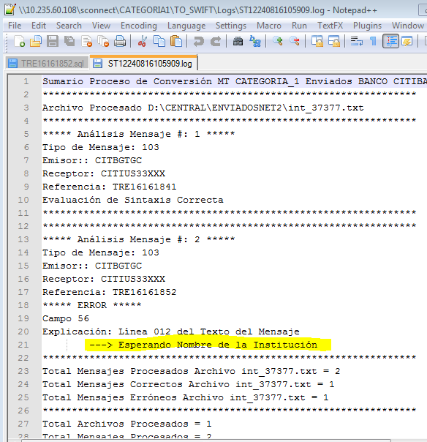

¿Cómo validar la información que falta?

* Revisar si el código ABA ingresado existe su registro en la base de datos:

select * from cob_comext..ce_fpddir --- Base de datos de los códigos ABA para confirmar su existencia

where fp_routing_number = '067009044' --- código ABA de la TRE

* Revisar información del banco intermediario relacionado a la TRE reportada:

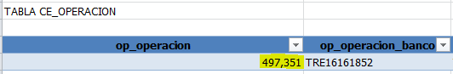

select * from cob_comext..ce_operacion_rol ---- Información del código ABA

where ol_operacion = 497351

and ol_rol = '10' --- rol 10 es del banco intermediario

Todo unido:

**select * from cob_comext..ce_fpddir**

**where fp_routing_number = (select ol_cod_aba from cob_comext..ce_operacion_rol**

**where ol_operacion = (select op_operacion**

**from cob_comext..ce_operacion**

**where op_operacion_banco = 'TRE#######')**

**and ol_rol = '10' )**